  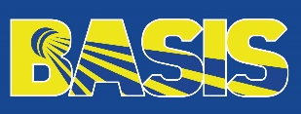 | Application Form  BEC Strategic Planning Day  &  World Academy of Sport Courses  Budaörs, Hungary  (1st - 3rd November 2019) |  |  |   
Organization Details  Organization:  Address 1:  Address 2:  City/Town:  Postcode:  Country:  Phone:  Personal experience  Please provide a statement detailing your education, current role within your federation, any other relevant experience and how you can contribute to the learning environment on the course.  (250 words maximum) |  |  | Personal Details - Candidate  Strategic Day (please tick if you wish to attend) ☐  Choose an item.  Course  Name:  Date of Birth:  Gender:  Phone:  Email:  Position in the  organization:  Expected learning outcomes  Please provide a statement detailing what you expect to get out of the programme and how your federation intends to use the outcomes to maximise the benefits of attending.  (250 words maximum)
The deadline to send the application form to Badminton Europe is on Monday, 23rd September 2019 before 12:00 CET. Please send the application form to Tania Teoh – tania.teoh@badmintoneurope.com

